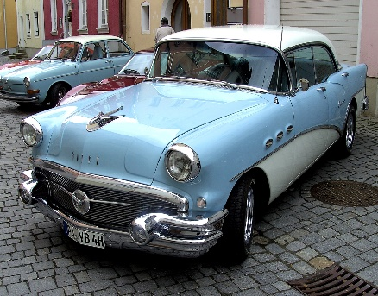

[This Photo](http://commons.wikimedia.org/wiki/File:Vintage_car_from_the_1950s.jpg) by Unknown Author is licensed under [CC BY-SA](https://creativecommons.org/licenses/by-sa/3.0/)

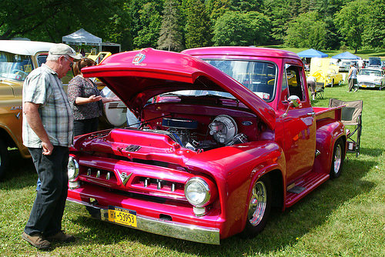

[This Photo](https://www.flickr.com/photos/jimduellcollection/20254370860) by Unknown Author is licensed under [CC BY-SA](https://creativecommons.org/licenses/by-sa/2.0/)

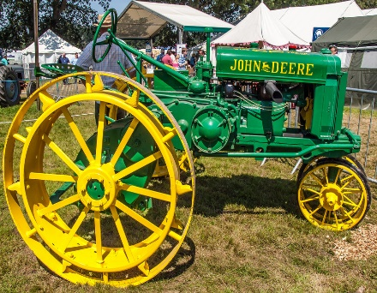

[This Photo](https://www.flickr.com/photos/anguskirk/7740293772/) by Unknown Author is licensed under [CC BY-NC-ND](https://creativecommons.org/licenses/by-nc-nd/2.0/)

**Scandia Taco Daze**

**Car, Truck, and Tractor Show**

**Registration Form**

* Saturday, September 10, 2022
* Sponsored by Stillwater Motors and Scandia-Marine Lions Club
* Music, food, and beer garden plus other activities and entertainment
* Non-judged exhibition and parade
* Guaranteed show space for first 50 registered vehicles
* Check-in and registration 9:30 - 11:30 a.m. at the Scandia Community Center
* Free registration includes dash plaque

Name

Email Address

Phone Number

Vehicle Type:

 Car

 Truck

 Tractor

 Other. Please specify:

Year Make Model

Please complete and mail this form to: George Galleberg, 10410 – 215th Street Court North, Scandia, MN 55073 or email it to:[ggalleberg@gmail.com](mailto:ggalleberg@gmail.com).