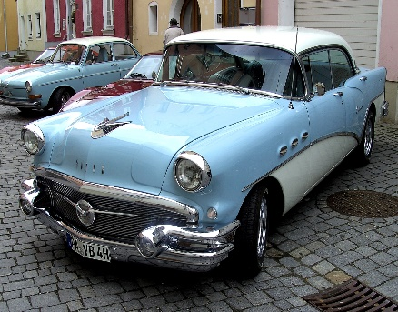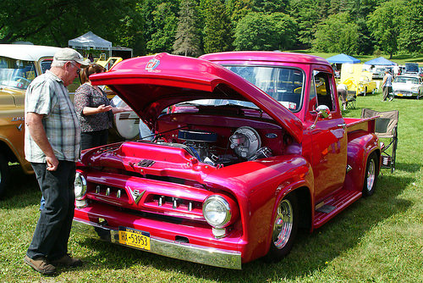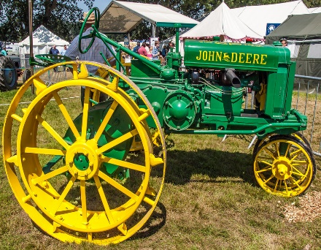
This Photo by Unknown Author is licensed under CC BY-SA
This Photo by Unknown Author is licensed under CC BY-SA
This Photo by Unknown Author is licensed under CC BY-NC-ND

Scandia Taco Daze
Car, Truck, and Tractor Show
Registration Form

- Saturday, September 11, 2021
- Sponsored by Stillwater Motors and Scandia-Marine Lions Club
- Music, food, and beer garden plus other activities and entertainment
- Non-judged exhibition and parade
- Guaranteed show space for first 50 registered vehicles
- Check-in and registration 9:30 - 11:30 a.m. at the Scandia Community Center
- Free registration includes dash plaque

Name
Email Address
Phone Number

Vehicle Type:

 Car
 Truck
 Tractor
 Other. Please specify:
Year Make Model

Please complete and mail this form to: George Galleberg, 10410 – 215th Street Court North, Scandia, MN 55073 or email it to:ggalleberg@gmail.com.

